**eWALL Application and Services**

**(part 3)**



**This document presents the application and services implemented in eWALL that can be used by the eWALL Open Source Community. The document belongs to eWALL consortium and any use of the document requires the reference to eWALL Open Source (http://gitghub.com/ewallprojecteu)**

# Table of contents

Table of contents 2

1 Web Applications 3

1.1 eWALL help 3

1.1.1 Background 3

1.1.2 Functionality description 3

1.1.3 GUI description 3

1.2 Notifications 4

1.2.1 Classification 4

1.2.2 Functionality Description 5

1.2.3 Notification construction mechanisms and triggering 6

1.2.4 Notification management and dispatching 7

1.2.5 GUI Design and device management 8

1.3 Cognitive Games 13

1.3.1 Memory Card Game 13

1.3.2 Memory Test Game 14

1.3.3 Memory Quiz Game 15

1.3.4 Functionality Description 15

1.3.5 GUI Description 15

1.3.6 Creation and personalization 18

1.3.7 Jigsaw 22

1.3.8 Sudoku 24

1.4 My Settings Application 26

1.4.1 Functional description 27

1.4.2 GUI description 27

1.5 My Kitchen Manager Application 29

Bibliography 34

# Web Applications

## eWALL help

### Background

The help application was a requested part of our eWALL system by a majority of users who participated in the small scale evaluation phase in all testing sites. The help application is presented in the form a instructional booklet through which the user can read the meaning and functionality behind each user interface element.

### Functionality description

In order to allow for understandable explanations and extension, we developed in parallel booklets for each testing site, edited the test site language. The help booklet is exhaustive in describing eWALL functionality and is independent from particular eWALL configurations. The reason for describing all eWALL functionality and not only the ones each user has access to, is to inform the user about other application they may find helpful, or interesting. Therefore each test partner has edited an instructional booklet and uploaded it in PDF format. Using a modified version of the TurnJS library (<http://www.turnjs.com/>) we render the PDF content into the book application.

### GUI description

Below we present an instance of the English help application. As illustrated in Figure 85, the user can interact with the booklet as with a real book. Flipping a page will render a page folding effect, giving the interaction a more natural feeling. This feature was appreciated by the test participants, as it was very familiar.

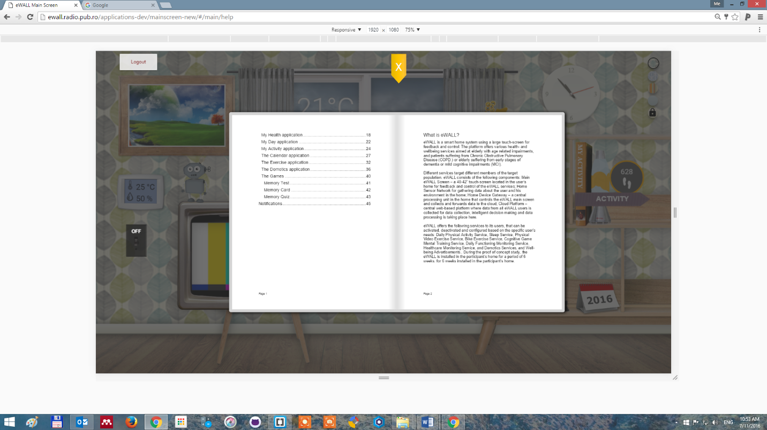

Figure 85: The help application GUI

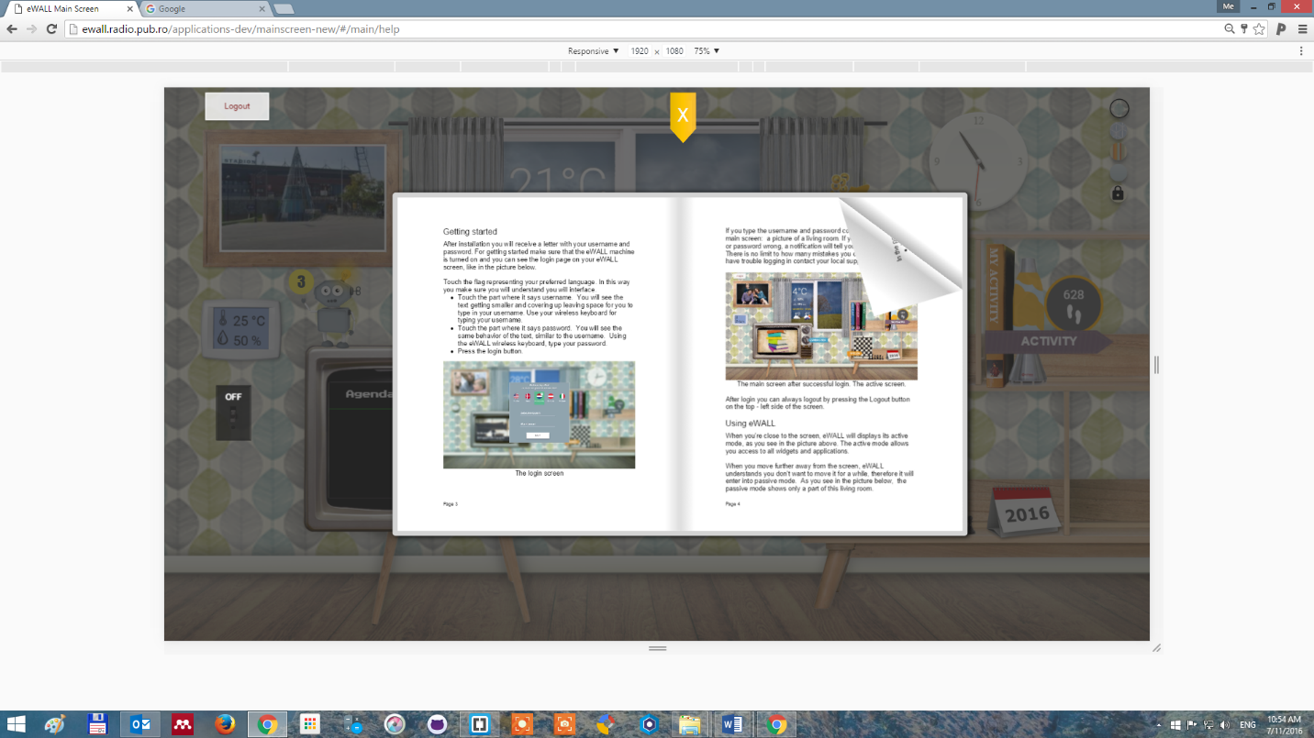

Figure 86: the Help application page flipping interaction

## Notifications

In eWALL we define user notifications as:

“*Either spontaneous informative message, or imperative requests for a user action, or user acknowledgement regarding an immediate issue.*”

What separates the eWall notification from the general concept of system notification is that they are the result of very different computational elements, e.g.: the intelligent decision support system, triggers notifications based on a continuous, ample analysis of the primary user profile; the sensor gateway can spot alarming situations and produces notifications as well, a calendar service brick will produce notifications based on its schedule.

We note that the majority of influencing factors in the notification triggering are external, ambiental and situational factors, unlike most computer systems (e.g.: operating systems, file managers, database systems), that trigger notifications describing an event in their internal state.

Notifications do not have the purpose of user driven data management. Their role is mostly to inform the user about imperative changes which happened in the present moment and on which the user must/should/could act upon. All data management is done using the eWALL applications; therefore some notifications will integrate shortcuts to the corresponding applications, when possible.

### Classification

Notifications are appearing in the main screen of eWALL, as well as (future feature) in the user’s personal smartphone. Based on the information they can be divided into the following types Table 32.

Table 15: A classification of eWALL notification types

|  |
| --- |
| Types of notifications |
| **Alarm**: addresses immediate critical situations that call upon actions due to the fact that they are life-threatening and/or property threatening. All alarms are propagated to secondary users. |
| **Appointment**: notifies time critical predecided meeting between two or more people, either for health, work or leisure. (concept) |
| **Reminder**: addresses action that the user must perform to maintain her/his wellbeing. Skipping of the action can lead to direct or indirect situations which may influence the user’s state of health, therefore performance of action is logged. |
| **Recommendation**: addresses action that the user could perform to maintain her/his wellbeing. Skipping this action does not lead to life threatening situations, therefore user feedback of accomplishment is not required. Some of these actions will be monitored through the daily life monitoring setup and time of action is considered in order to match recommendation with corresponding user action. Recommendations are presented to the users in the form of welding advertisements,shown in the TV widget. |

### Functionality Description

Notifications can be categorized/enriched with meta-information which allows the system to know how to handle them during their *lifecycle*.

The Meta information defines, as an example, if the notification requires a feedback (explicit acceptance action from the user or automatic feedback from the system when possible); also, it defines a level of importance for the notification, which represent how dangerous it would be if a feedback is not provided.

Example:

* a notification (e.g.: recommendation) which suggests the end user to go out for a walk, if not acknowledged, does not create a potentially dangerous situation for the end user
* a notification (e.g.: recommendation) for medicine intake, when the medicine is very important (e.g. heart disease), when not acknowledged might indicate a potentially dangerous situation

**Notification lifecycle:**

* Configuration
  + from the portal, made by different roles
  + from the system (e.g. reasoners) based on universal criteria
* Possible configuration items:
  + selection of the type, messages, conditions for the triggering
  + define if “ACK” is required
  + select a policy to associate
* Triggering
  + the eWALL system triggers the notification (e.g. identify conditions for the raising of the notification and create it)
  + the user triggers a notification
* Dispatching
  + Based on the policy associated to the notification and on the user profile (and associated actors), the system decides the format, how to dispatch it, the recipients and the target device
* Management on the device
  + Visualization on the screen
  + Relationship with other notifications
* Feedback management:
  + if feedback required, manage both case: feedback received/ not received
  + if feedback not received, other actors might be notified according to the policy.

### Notification construction mechanisms and triggering

Typically, notification re constructed by the various reasoners implemented in eWALL. As an example we presented the current implementation approach focusing on intelligent decision support reasoners.

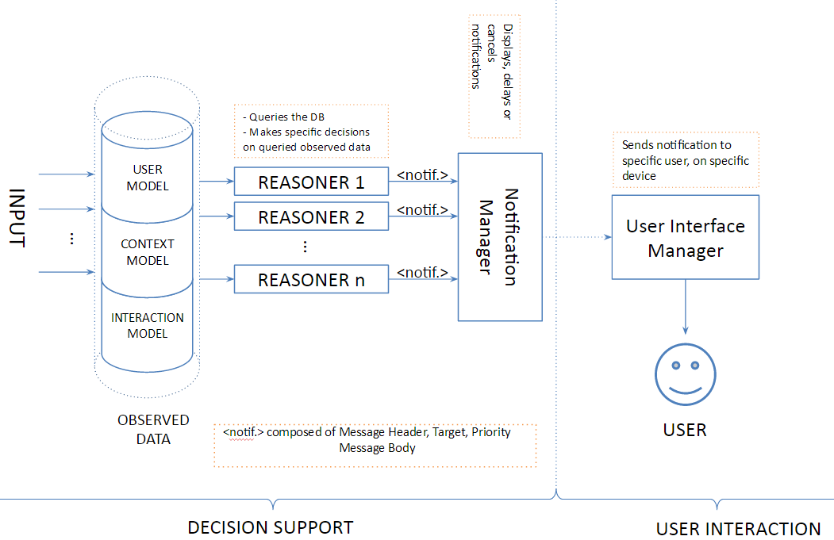

Figure 87: A diagram illustrating the IDSS notification construction mechanism

In Figure 87thedecision support reasoners are querying the observed data set and taking into account the user model, context model, and interaction model, they build notifications accordingly. At the moment of writing, the activity coaching reasoner can generate a general notification. We use this data model as an initial support for our notification end-2-end functionality implementation.

A notification consists of several parts:

* a type - Which describes notification type according to the classification above;
* a set of statements - which refer to the content/ message of the notification. This can be a composition between text and several images
* a set of feedback elements - all notifications require user feedback in order for the platform to continuously learn about user preferences and response to various types of notifications. A feedback element consists of: a type - [button, check box, slider, etc.], a label and most importantly a feedback URL which is called on user interaction with the feedback element.

Below is an example of such a notification data model:

{

type:”reminder”,

statements:[

motivational:"You have taken more rest. Regular activity reduces health risks.",

suggestion:"Take a nice walk!"

],

feedback: [

{

type:"button", // string – can be “button”, or “checkbox”

label:"OK", // string – max 8 chars, all caps

url:"" // string – the use to be call when according to the expected feedback

}

]

}

### Notification management and dispatching

Notifications require a predefined level of management, so that the end users are not overloaded by all information coming randomly from independent notification sources. Currently, the notification management and dispatching process consists of several distinct context-aware features, such as:

* **Prioritization of notifications.** Notifications are managed and queued for dispatching based on priority coefficient carried in the notification message. Notifications with lower values of the priority coefficient have higher priority for dispatching.In this manner the user is constantly updated with the most crucial notifications in a timely manner.Additionally, the notifications with highest priority are treaded as *alarms* and are dispatched to the users immediately.
* **E-mail based dispatching of notifications.** The highest priority notifications are also dispatched via e-mail service towards the primary user, informal and formal caregivers. In this manner all caregiver personas (i.e. informal and formal caregivers) can be instantly informed with the wellbeing and status of the primary user of interest, in the case of an emergency.
* **Location based dispatching of notifications.** In order to facilitate a ubiquitous notification feed towards the primary user, all notification messages can be dispatched towards the target UI device of interest, based on the user’s location.For example, if the user is located in the living room, the pending notifications will be dispatched and presented on the eWall main screen. If the user is outdoor or in some other room, the pending notifications will be dispatched and presented on the user’s hand held (i.e. mobile) device.

The Notification Manager represents the main processing entity responsible for the notification management and dispatching. More details regarding its functionalities and operation can be found in deliverables D4.4.1 and D4.4.2.

### GUI Design and device management

Usability test have shown that spontaneous notifications are not perceived as suggestions for all the participants.Some considered this functionality too demanding. In order to strengthen the platform messaging, increase user adherence and create a sustainable, expandable intelligent notification system, we have redesigned the communication between IDSS components and the user.

**Introducing Robin the robot, a personification of the eWALL system intelligent decission support**

Robin the robot is a personification of the eWALL intelligent platform, who will carry out conversations with its users (cf. Figure 88).Based on the previously described notification data model, we can perform an exchange of messages between user and Robin. Robin has the capacity to inform the user about changes in her/his lifestyle which have negative or positive influence on the user’s health. In these cases, Robin will pop-up on screen and display a conversation message.



Figure 88: Robin the robot, as displayed by the eWALL main screen

At the moment of writing, the reminders are generated by the Virtual Coach IDSS reasoner. Recommendations do not pop-up on screen. Robin collects them and displays a counter, allowing the user to decide when they want to browse through the notifications. The same principle can be seen in social networks like Facebook, or Twitter.

* b) 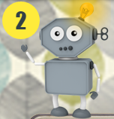

Figure 89: the icon of Robin the robot, as displayed by the eWALL main screen: a) when no reminders are collected; b) when 2 reminders are collected

The user can also initiate conversations with Robin. These conversations mimic the interaction from role playing games. In the example below, the user Bob has touched Robin‘s icon from the main screen and this is the effect.

**Reminders and conversations for virtual coaching**

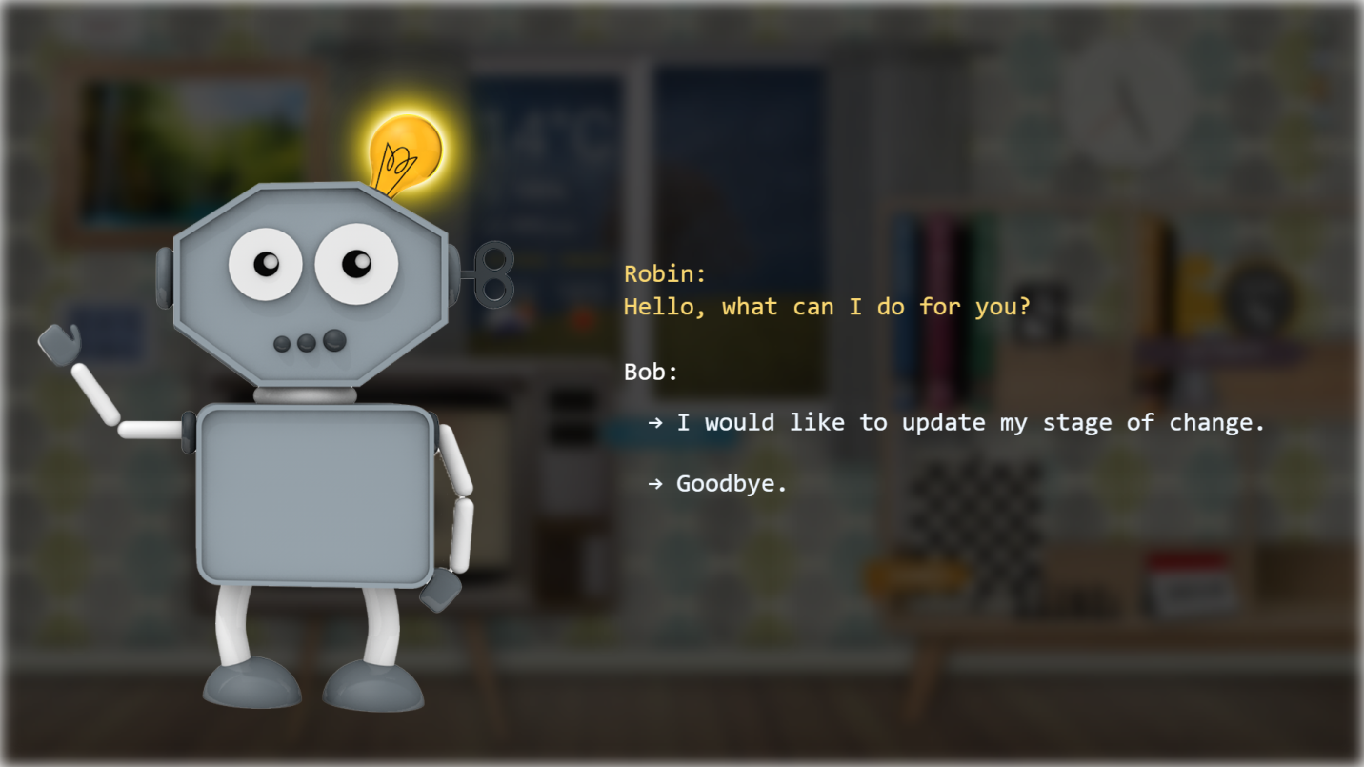

Figure 90: Robin the robot, displaying the first dialogue in a user initiated conversation

When the user chose to update his state of change, Robin display’s several options:

* Taking the action of updating the user’s stage of change will result in a short conversation in which the user will answer with the necessary input for a stage of change evaluation. This functionality was previously meant to be assessed via a questionnaire. When asked, potential primary users prefered the conversational interaction.
* Getting information about the stage of change. This is essential for novice, or first time users of eWALL. The user will get informed about the meaning of this information, how it relates to him and the effects the information has on the eWALL system. All information requested from the user is voluntary and the user always has the option to end/quite the conversation.
* Launching relevant applications. Throughout the conversation, Robin may offer the option to launch a specific application, because hi’s message raised awareness about a topic which has a relevant eWALL application enabled for the user.

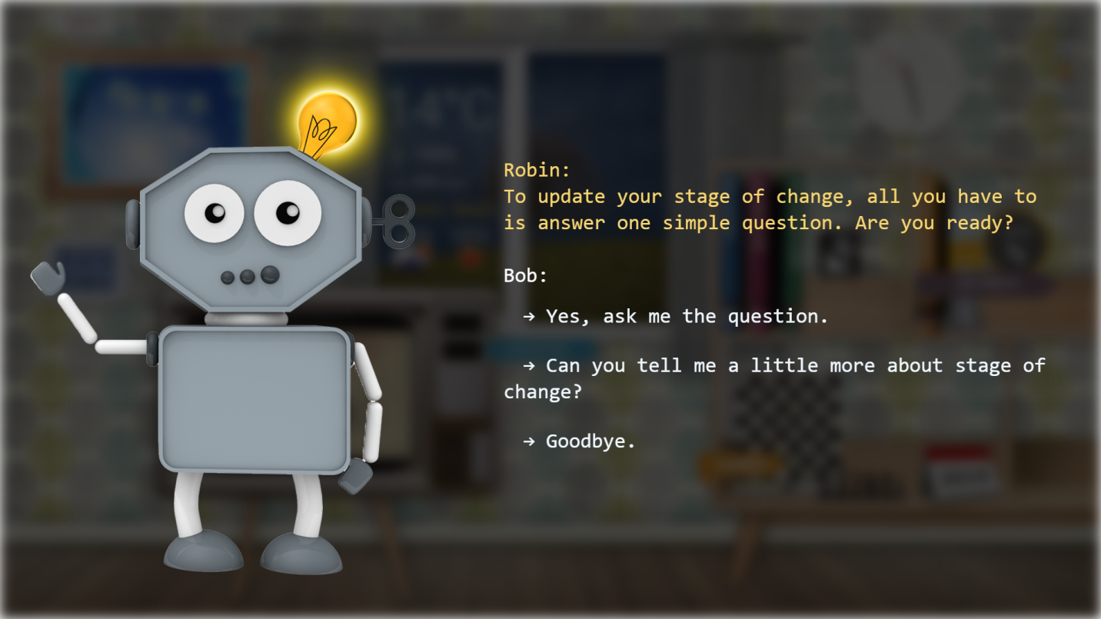

Figure 91: Robin the robot, displaying an intermediary dialogue in a user conversation

**Alarms**

Alarms are built as a distinct layer, on top of all interfaces, including the above mentioned conversational reminders. They will interrupt user interaction and display regardless of the screen state, on top of every UI element.

Robin takes a distinct red helmet, to indicate that the alarm is not part of the conversation, even if the alarming situation will happen during such a conversational moment.

In the example below, we illustrate how eWALL represents alarms in the current implementation.

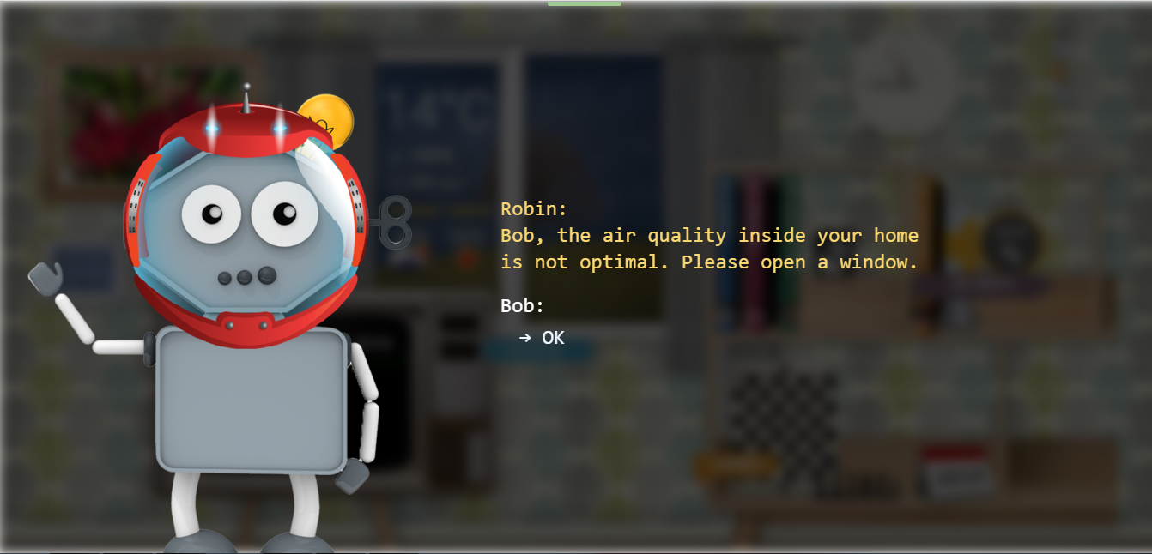

Figure 92: Robin the robot, displaying an alarm

**Future work**

We are exploring the possibility of generating coherent and human like communication between Robin and the user. Our future aims are to explore the feasibility, both from the user side and the technology side, of speech synthesis. This will allow Robin to speak its messages, a highly useful feature for alarms.

Recommendations address action that the user could perform to maintain her/his wellbeing. They are purely optional. In order to make a clear distinction between this type of notification and the rest, a different communication strategy was adopted. We use advertisements, displayed in the TV widget, which target the user‘s wellbeing behavior within the context of using eWALL.

When the main screen is in passive mode, the advertisements are displayed enraged and in the center of the screen, targeting higher engagement from the user.

|  |  |
| --- | --- |
| ad-1-bike-EN.jpg | ad-2-sleep-EN.jpg |
| ad-3-video-EN.jpg | ad-4-cognitive-EN.jpg |
| ad-5-breakfast-EN.jpg | ad-6-music-EN.jpg |
| ad-7-social-EN.jpg | ad-8-book-activity-EN.jpg |
| ad-9-book-sleep-EN.jpg | ad-10-book-health-EN.jpg |
| ad-11-book-day-EN.jpg | ad-12-book-help-EN.jpg |

Table 16: the English illustrations which represent wellbeing recommendations.

## Cognitive Games

### Memory Card Game

The Memory Card Game is a traditional cognitive training game, in which all of the cards are laid face down on a surface and two cards are flipped face up over each turn. The object of the game is to turn over pairs of matching cards – Figure 134. The game starts when the player selects a random card. The user is expected to memorize the flag and its position. On the next step the user select second card if they are with the same flag the cards will match and stay open, the game have to continue with a new card. If the flags are different, the cards will be closed again and you have to start continue until you match all the flags.

The came continues until all the cards are paired.

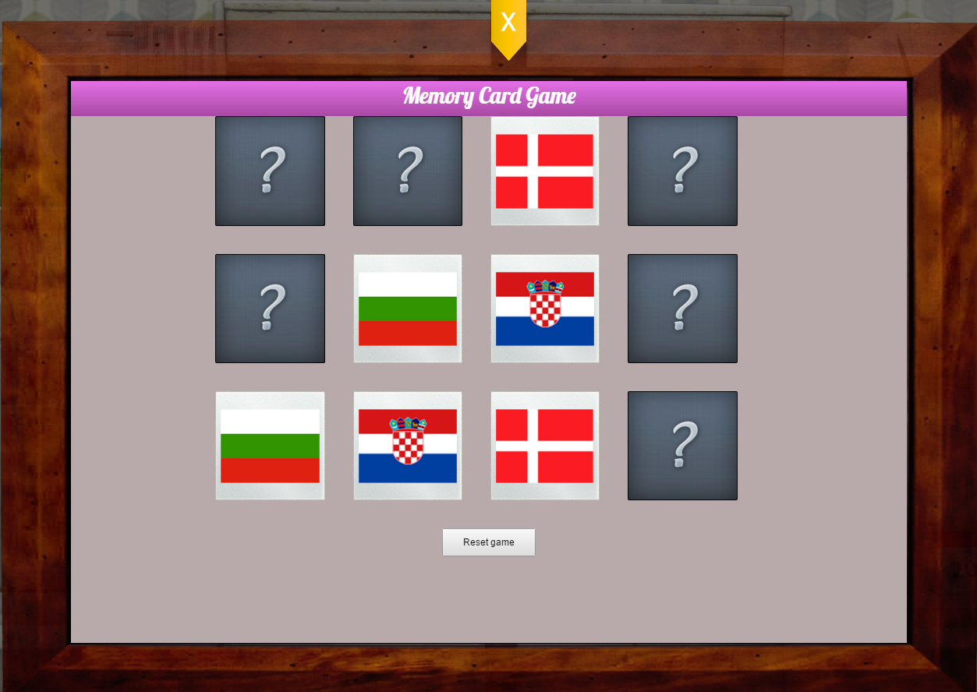

Figure 93: Sample of the Memory Card Game

The eWALL user is able to choose between three levels of difficulty which varies in terms of card numbers:

* *Easy*- with 2x4 cards (8 cards)
* *Medium* – with 3x4cards (12 cards)
* *Hard* – with 4x4 cards (16 cards)

As feedback for assessment of the eWALL user cognitive performance the game provides possibility to collect and show the results in terms of time needed to complete a single game and number of clicks.

### Memory Test Game

The Memory Test Game helps the eWALL users to improve their memory by trying to memorize the positions of each of the numbers. In the initial game-play screen (cf. Figure 94) the player sees all the numbers from 1 to 9. The goal of the game is to memorize all numbers position and open them in sequential order starting from 1. Tree levels of difficulty are available for the user to choose from, they defer in the number of the numbers that the user is supposed to remember. The three levels are with complexity as follows:

* *Easy*- with 4 numbers
* *Medium* – with 6 numbers
* *Hard* – with 9 numbers

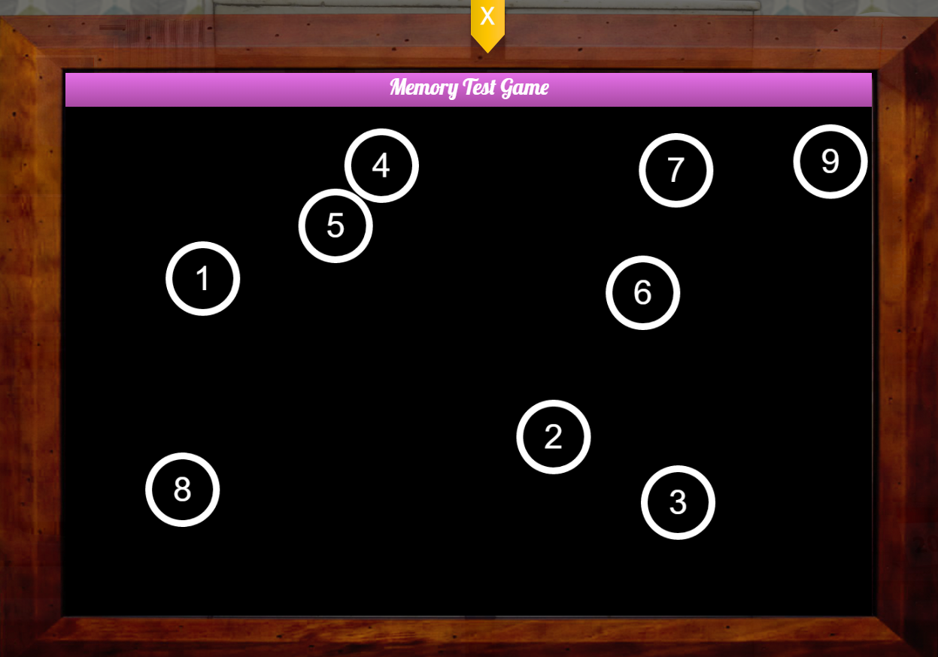

Figure 94: Initial game-play screen of the Memory Test Game on level "hard"

A screen shot or the game-play is given inFigure 95. In brief the rules of the games are as follows:

* Step 1.Try to memorize the place of each number.
* Step 2. Start with clicking on number 1, and the rest of the numbers will be hidden.
* Step 3. You have to open them in consecutive order up to 9.

Every time the game is renewed the numbers have different position.

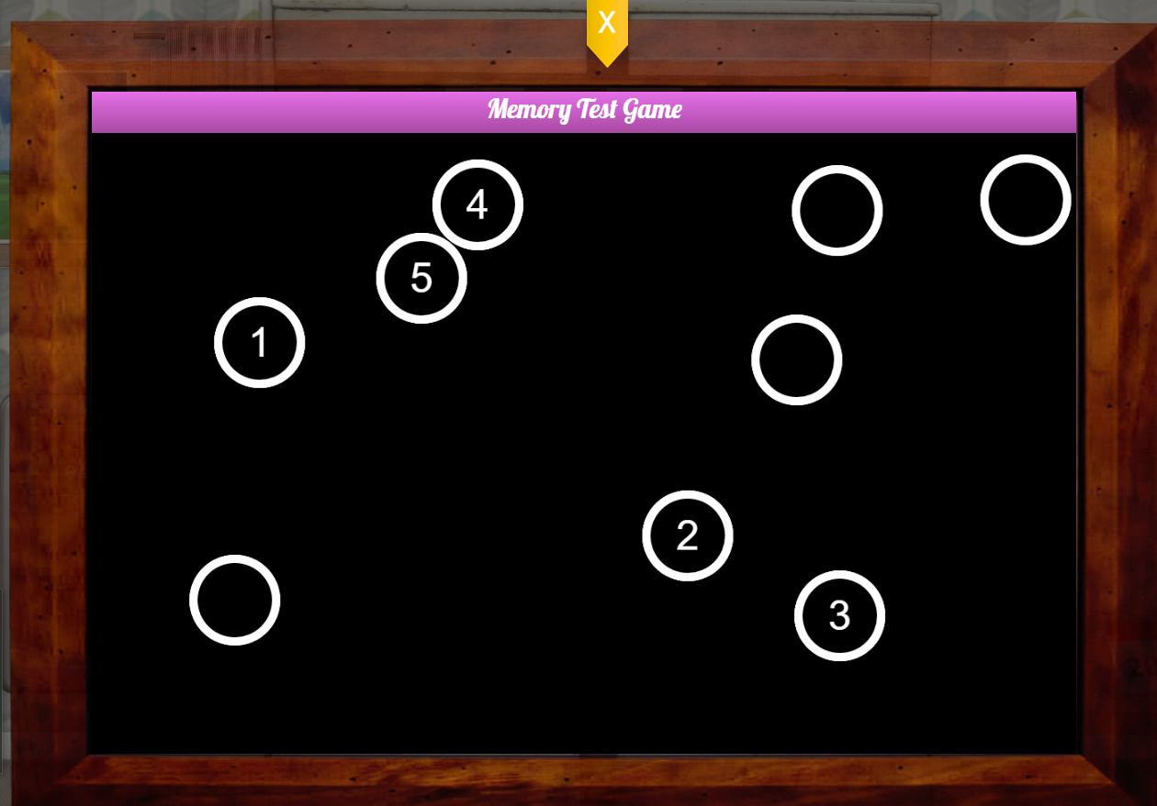

Figure 95: Memory Test Game: Game-play screenshot

### Memory Quiz Game

eWALL users are people with memory degradation issues, therefore a visual quiz game can help them to strengthen their memory and even to recover memories of family, friends, places, etc. The Memory Quiz Game is a visual memory quiz with multiple-choice questions (based on the user’s photo gallery) regarding the user's previous experiences, acquaintances, etc. The Memory Quiz Game consists of several components.

The Memory Quiz Game web application is the user interface for the actual game itself. It allows the user to answer questions and provides him feedback regarding the correctness of the answers. The actual quiz topics (e.g. General, Family, Friends, Travelling, etc.) and questions are user-specific and can be created, modified and deleted by the caregivers through the dedicated “Settings” area of the Caregiver application.

### Functionality Description

The Memory Quiz Game uses data provided by the Memory Questions Management service brick (Section 5.11) to offer the user the following functionality:

* Quiz topic selection. The topics displayed to the user are the demo topics and the user-specific topics.
* Question answering. The questions are randomly chosen from the specific topic selected by the user.
* Answer validation and feedback. In the end a score summary and a questions summary is provided and the user can review the questions to see the correct and incorrect answers.
* Statistics. In the end the user is provided with a statistic of previous results in order to be able to assess his performance trend.

### GUI Description

The GUI of the Memory Quiz Game consists of several pages as follows:

* A welcome message is displayed as a first page of the application.
* The topic selection page – here the user can select the topic to play with.
* The question answering/review page – is updated and displayed for every question to be answered or reviewed by the user.
* The results page – is displayed after the quiz is finished and shows the quiz summary and statistics regarding previous results.

A snapshot of the topic selection page is illustrated inFigure 96. The page displays the quiz topics available for selection. When the user clicks on one of the topics the question answering page is displayed.

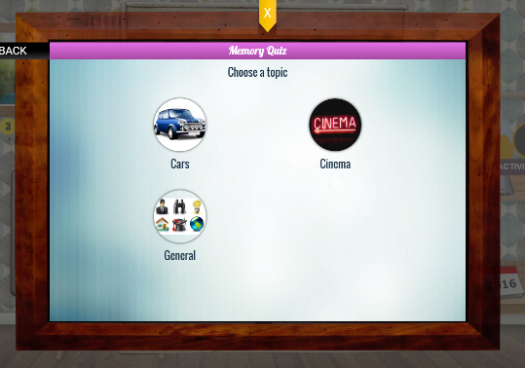

Figure 96: Memory Quiz Game – Welcome page

A snapshot of the question answering page is illustrated inFigure 97. The page displays a button to stop the game and go back to the topic menu, the question and four visual answers (pictures). Optional text answers (captions) may be displayed below each picture. When the user clicks on one of the pictures the question answering page is updated to display the second question and so on, until all the questions in the quiz are displayed and answered to. The user has also the possibility to skip one question or going back to a question already answered through the selection bar at the bottom of the screen. This selection bar allows the user to easily understand what are the questions already answered and the missing ones. Finally, the results page is displayed.

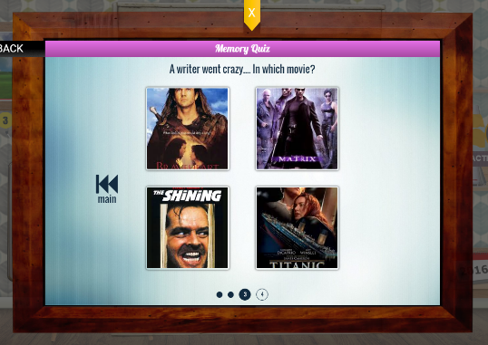

Figure 97: Memory Quiz Game – Question answering page

A snapshot of the results page is illustrated inFigure 98. The page displays a message informing the user about the overall rating, the percentage of correct answers, how many questions he/she managed to answer correctly (highlighted in green) and how many questions had a wrong answer (highlighted in red) . The user can touch on the number of correct/wrong answers to see details regarding the questions, and selecting a particular question will be displayed the correct answer and the wrongly chosen answer (if the case). The correct answer is marked with light green, while the wrongly chosen answer (if the case) with red. This behavior is illustrated inFigure 99. The question review page marks

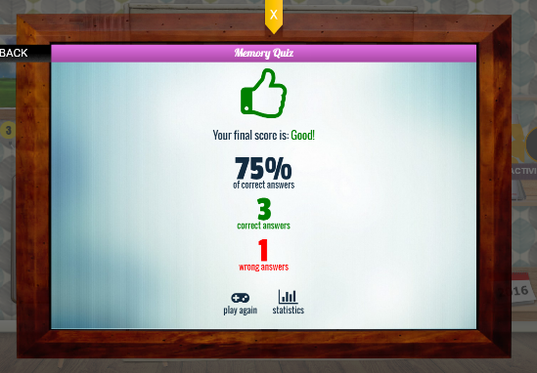

Figure 98: Memory Quiz Game - Results page

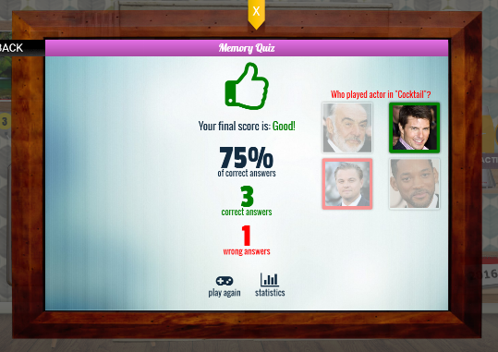

Figure 99: Memory Quiz Game – Question review page

The results page also contains a “Statistics” button which can be clicked to display the statistics page (cf. Figure 100).

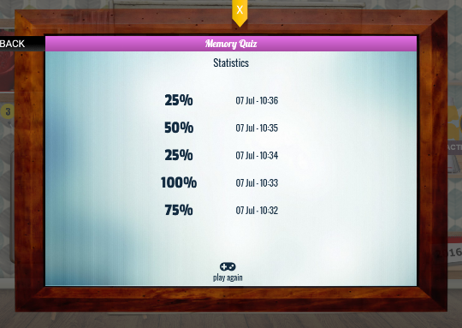

Figure 100: Memory Quiz Game - Statistics page

The statistics page displays the percentage of correct answers provided by the user for this quiz topicduring the most recent games. The statistics page also contains a “Play again” button which can be used to return to the topic selection page (cf. Figure 100).

### Creation and personalization

A dedicated section in the “Settings” area of the caregiver application provides the user interface for the administration of the Memory Quiz Game. It allows the caregivers to edit and adapt the quiz to each particular user, more specifically to create, update and delete quiz topics and questions. This feature (per user adaptation of the Memory Quiz Game) is of critical importance, because one needs user-specific questions to stimulate the primary user’s memory.

The application uses endpoints and data provided by the Memory Questions Management service brick (Section 5.11) to offer the user the following functionalities:

* Browse and upload user-specific pictures the eWALL Private Cloud storage area. These pictures are needed to create questions with visual answers, and are private to the primary user and his/her caregivers.
* View, create, update and delete user-specific quiz topics.
* View, create, update and delete user-specific quiz questions.

The entry point to the configuration, as mentioned, is the “Settings” area of the caregiver application (cf.Figure 101).

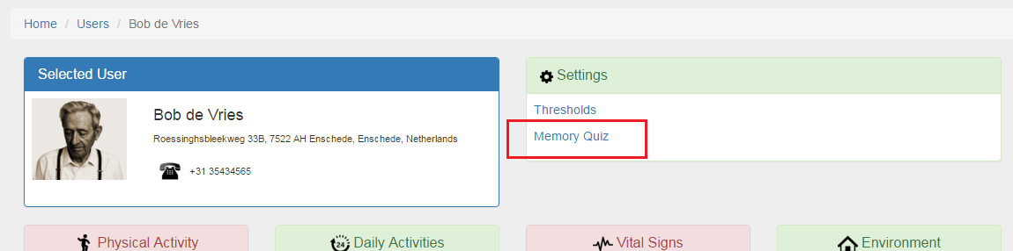

Figure 101: Access to Memory Quiz Game configuration

Clicking on the “Memory Quiz” link, the main configuration page shows up (cf. Figure 102) with the list of already configured topics for the quiz and a set of buttons allowing tocreate new contents.

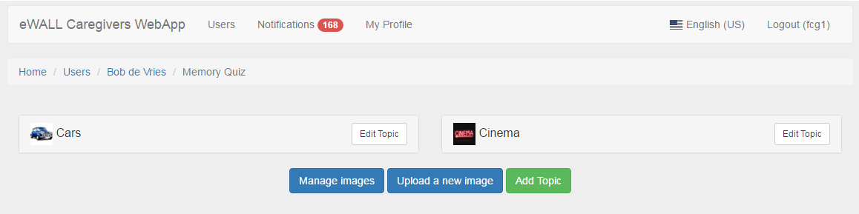

Figure 102: Memory Quiz Game administration main page

In the above sample, two topics are already configured.

The caregiver can upload new images by selecting the “upload a new image” button; a pop up allows to select a picture from the local storage and to upload it into the system, providing a textual tag. An important thing to notice about this feature is that, if the configuration is made via smartphone, it comes very handy to take pictures on the fly form the primary user environment and create a personalized game with them, as an example with pictures of details in the rooms (furniture, devices, books,..) or people (kids, grandsons, ..).

By clicking on “Manage images”, a pop up window displays the set of images currently available for selection in the system, as shown inFigure 103.

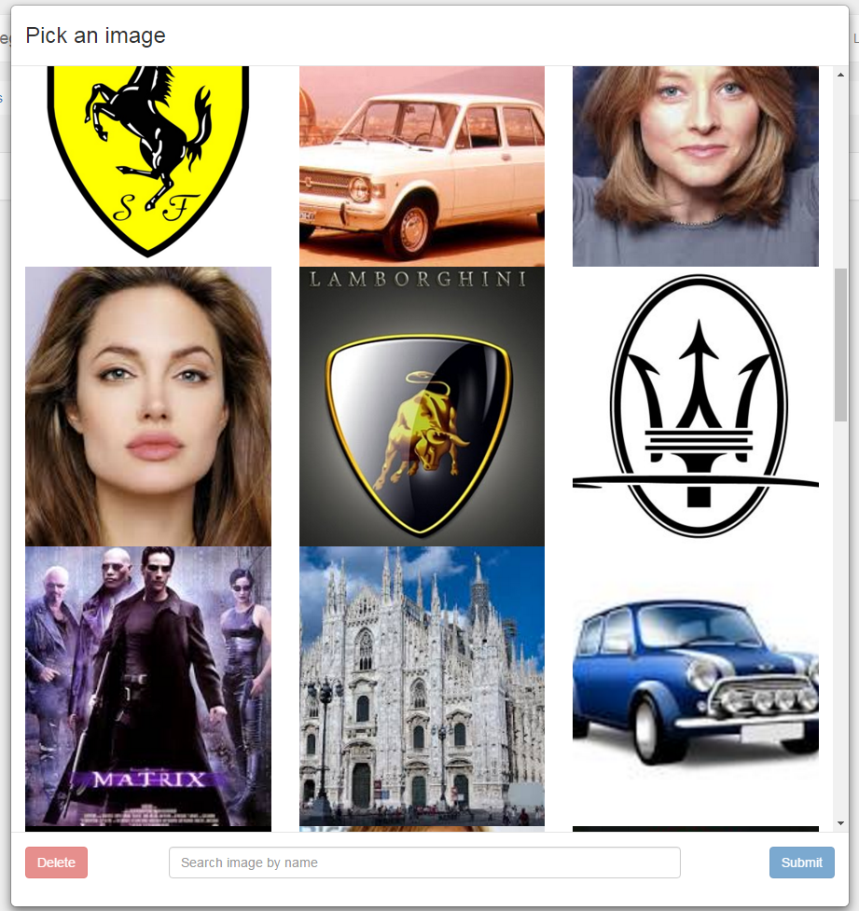

Figure 103: Images management

By selecting the “Edit topic” button, it is possible to change the information defining a specific topic (cf.Figure 104), namely the topic name, the number of questions for every quiz, the topic icon, or delete the topic itself.

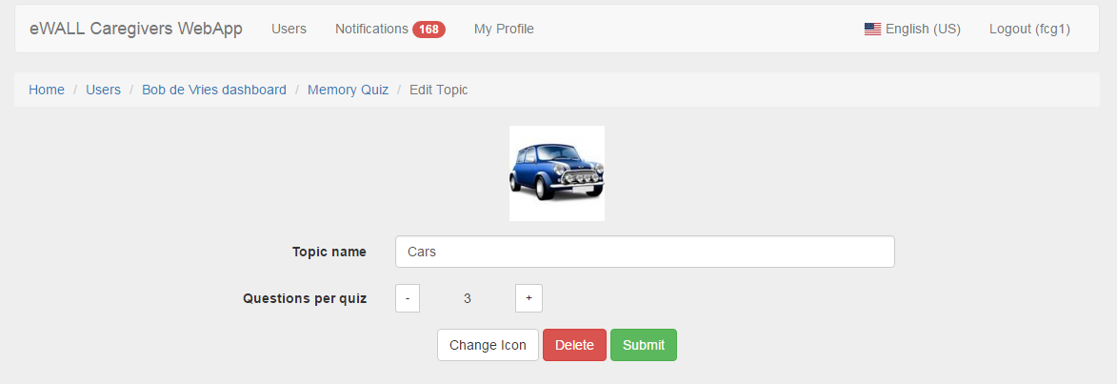

Figure 104: Topic settings

Instead, by selecting the topic name, it is possible to see, edit or delete the questions associated to that topic (cf.Figure 105). As well, selecting the “Add Topic” button, the same mask appears but without values in it.

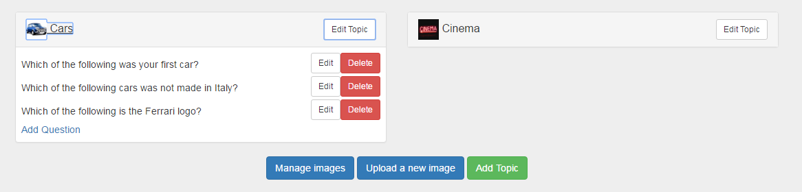

Figure 105: Set of questions for a specific topic

Clicking on the “Edit” button for a specific question, it is possible to set all the details such as: the question text, the set of pictures, the definitionof the correct answer (cf.Figure 106).

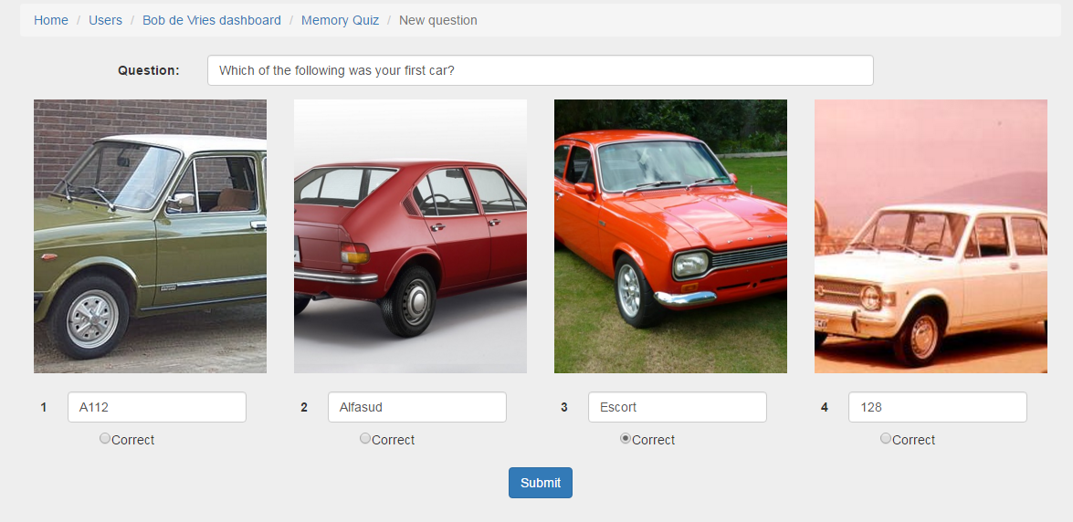

Figure 106: Question configuration

By clicking on a picture, in case the caregiver wants to change it, a window pops up (cf.Figure 107) for choosing one of the image available in the system (previously uploaded by the caregiver for that specific primary user). Similarly, it is possible to create a new question by clicking on the “Add Question” link and filling in the question text, the pictures and selecting the correct answer.

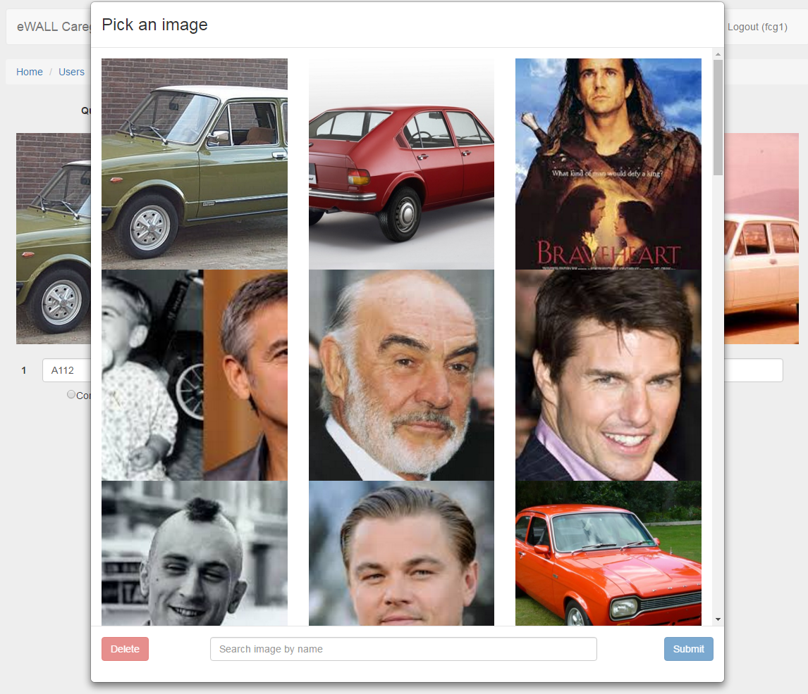

Figure 107: picture selection

### Jigsaw

Jigsaw games have been identified by the eWALL medical partners, experts in the MCI field, as valuable means to maintain memory and attention. This game, in addition to training the logical and memory skills, allows also to involve the primary user with physical touch-based interaction with the screen.

In eWALL, we want to maximize the possibility of user involvement by providing the possibility, in the same way as for the Memory Quiz Game, of customizing the contents. Therefore, the eWALL Jigsaw game allows the users to play with custom pictures uploaded by the caregiver, which can be more attractive for the primary users.

The first page of the Jigsaw web application (as shown inFigure 108) welcomes the user with a message and the list of the pictures availables for playing.

In addition to the custom pictures uploaded by the caregiver, the primary users can also play with default pictures provided by the eWall platform. From this view, after selecting the desired picture, the difficulty level needs to be selected (easy, medium or hard). The increasing level of difficulty is given by the number of tiles in which the picture is splitted.

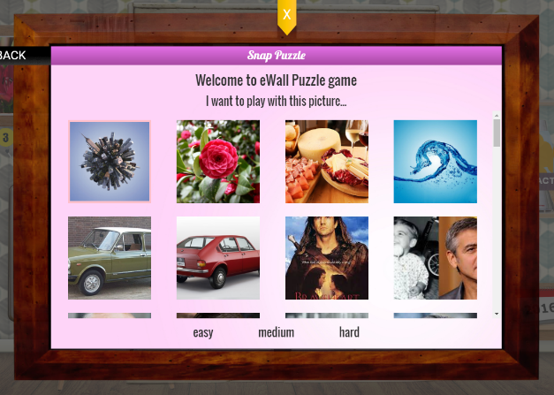

Figure 108: Welcome page of Jigsaw game

The core of the application is shown in Figure 109: this game allows the primary user to compose a picture by drag-and-dropping small picture “tails” from the right side of the game area into a dedicated area (the white one on the left part of the screen), to compose a unified picture. The user have in every moment the possibility to restart the game or to start a new one, with a different picture and/or a different level.

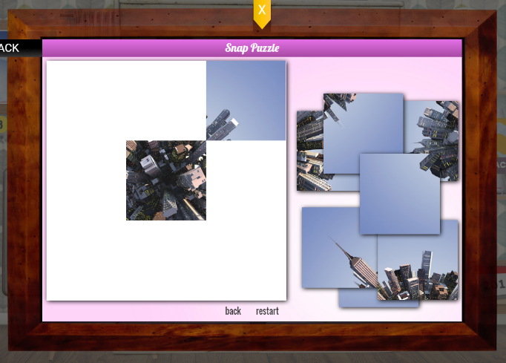

Figure 109: Jigsaw game

When the user drags all the tiles in the correct position, the game is finished and a congratulation message appears on the right side of the screen, as shown in Figure 110.

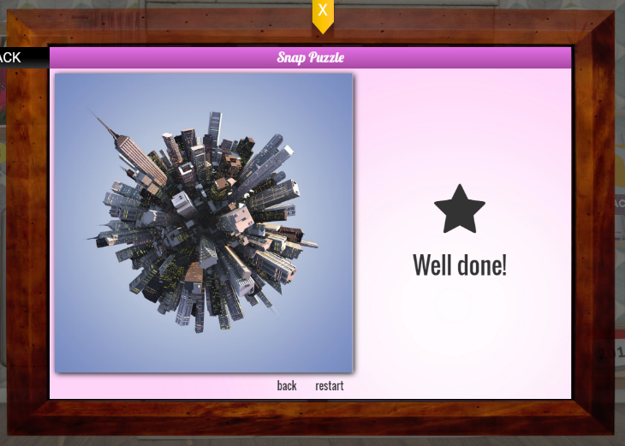

Figure 110: Jigsaw game finished

### Sudoku

Sudoku is considered one of the most effective games related to logical deduction and problem solving. Being it a well-known, widespread game, appreciated by people spanning from very youngto elderly people, the eWALL medical partners selected it for inclusion in the final version of the platform.

One of the most important aspect in the Sudoku game developed for eWALL is the possibility of changing the difficulty level to stimulate the primary user to train on it iteratively. For this reason, the eWALL Sudoku game welcomes the user with the choice of the level (Figure 111). This choice impacts the number of cells to be filled in order to complete the game. After the selection of the level, the game can start: the user interface was developed to guarantee an intuitive full-touch experience (Figure 112). The Sudoku can be solved filling the empty cells in the grid simply touching on them and selecting (possibly) the correct value among the proposed ones (1 to 9, plus a ‘-’ symbol to empty an already filled cell). This scenario is displayed in Figure 113.

Moreover, a helping mechanism was implemented: whenever a user tries to insert an illegal value (that is, according to Sudoku rules, a value already present in the same row, column or block), that value is highlighted in red. In this way, the final user has an immediate feedback on how the game is proceeding.

In every moment, the final user can use the “Back” button to going back to the “Selection level” menu to start a new game, changing the difficulty level if desired. When the user wants to quit the game, it is possible to view the Sudoku solved touching the “Solve” button. If the user have inserted any correct values, they are highlighted in green: in this way, a user is able to easily understand how far he (or she) was from the game ending and will be stimulated to improve.

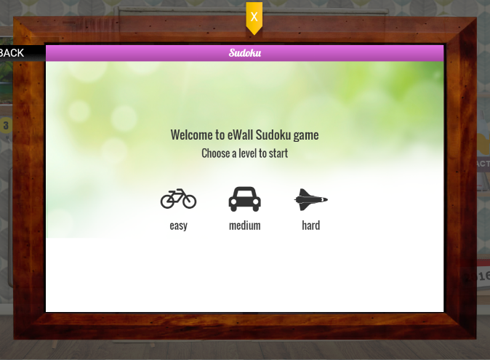

Figure 111: Welcome screen of Sudoku game

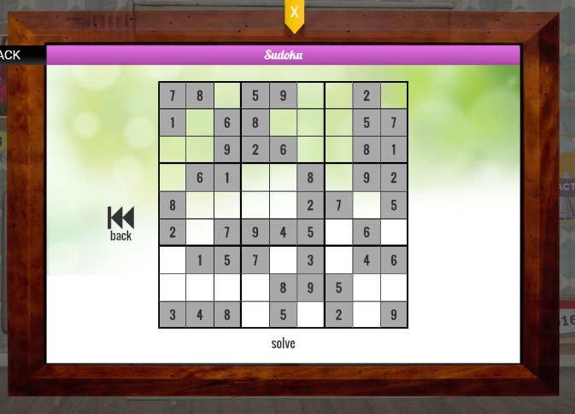

Figure 112: The eWALL Sudoku interface

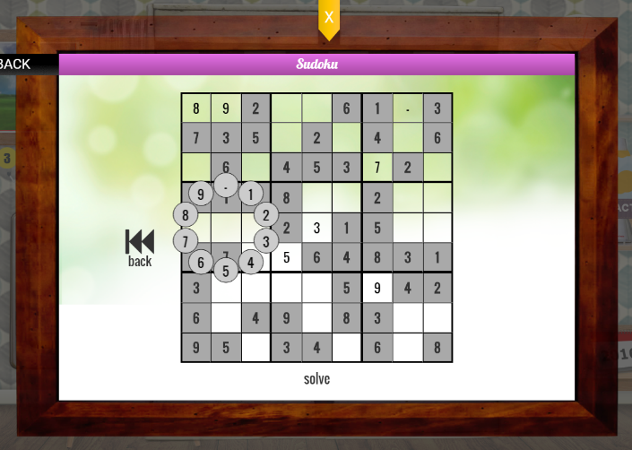

Figure 113: Inserting a value in a Sudoku cell

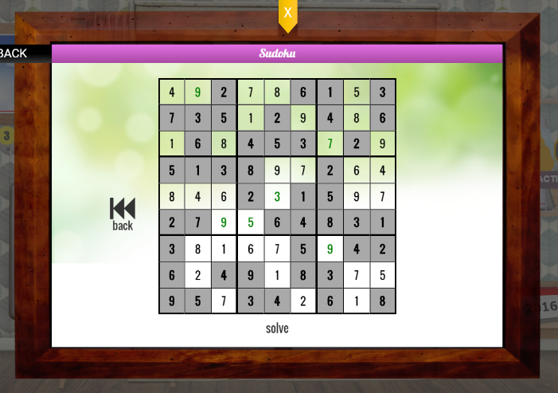

Figure 114: Sudoku solved

## My Settings Application

Allowing users (being it patients with age-related impairments, mild cognitive disorders, or COPD) to manipulate their own settings allows them to experience a more satisfying degree of personalisation [76], increases feelings of control and allows for a higher degree of privacy. Moreover, providing end-users with the right options with respect to storing and sharing personal (health) data, enables the technology to comply with European privacy legislation. Finally, it also allows the user to correct eventual errors of automatic setup.

### Functional description

The primary user is able to change settings in his/her user profile, a specific app within eWALL.

The user is able to set:

* his/her user data
* preferences in notification types
* preferences for wellbeing advertisements
* settings for widgets (e.g. select different clock styles)

This can primarily be done on a very abstract level, so as to optimize ease of use. Therefore, users will have a maximum of three choices (see use case below) when it comes to settings related to sharing, and notifications. Changing user data will be restricted to demographic information which can be changed via a simple web form. Alternatively, these settings can be changed via a dialogue with the notification robot, who can initiate a dialogue upon request of the user related to a specific setting, including options for altering the setting. The notification robot will then change the settings in the back-end system.

### GUI description

The MySettings application starts by pressing the MySettings icon from the main screen. The MySettings icon is located top right on the main screen next to the clock. When the app is opened, it is shown an overview where we can select ‘Sharing data with others’, ‘My Notifications’, and ‘My eWALL appearance’ (Figure: 115). Taping on the each button opens the corresponding page.

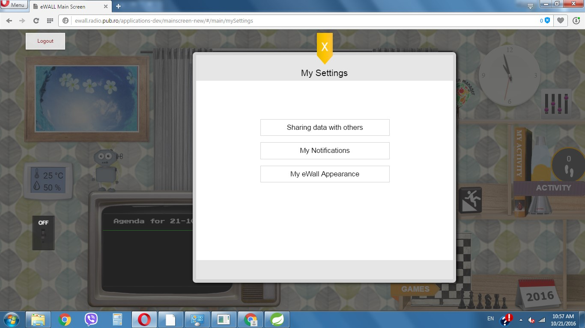

Figure: 115 “My Settings” Application

If the user selects ‘Sharing data with others’, he will have to select one from these categories: ‘Nobody’, ‘Everybody’ and ‘Let me decide’ (Figure 116). The selected one is in green while the others are white. If user doesn’t want to share information with others he must select “Nobody”. If he select “Everybody” then he will give access to his personal information (address, data about his sleep, daily physical activity, daily life) to everyone who is registered as caregiver. When the user clicks on ‘Let me decide’, he will have the choice to give an access to his personal information to selected caregivers and family people. Selected people are paint in orange, while non-selected are white. When the user has made his selection he must click on “Save” button. With “Back” he returns back to main page of the app.

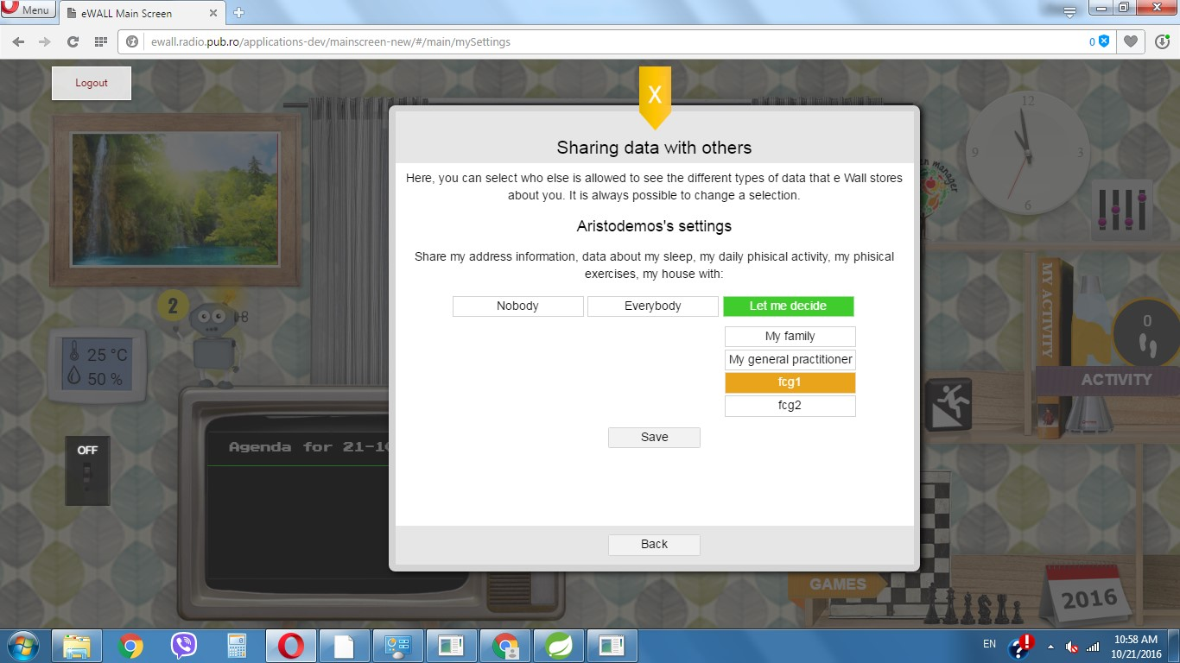

Figure 116: Sharing data with others

When the user goes another step back and visits the ‘Notifications’ option, where he can set which types of notifications he does and does not want to receive, and how often (Figure 117). Under every topic (health advice, house information and medical signs) the user sees the options ‘Never’, ‘Only when something is wrong’, and ‘Keep me updated constantly’. The selected one is painted in green while the others are in white. User changes must be saved by clicking ‘Save’. With “Back” the user returns back to main page of the app.

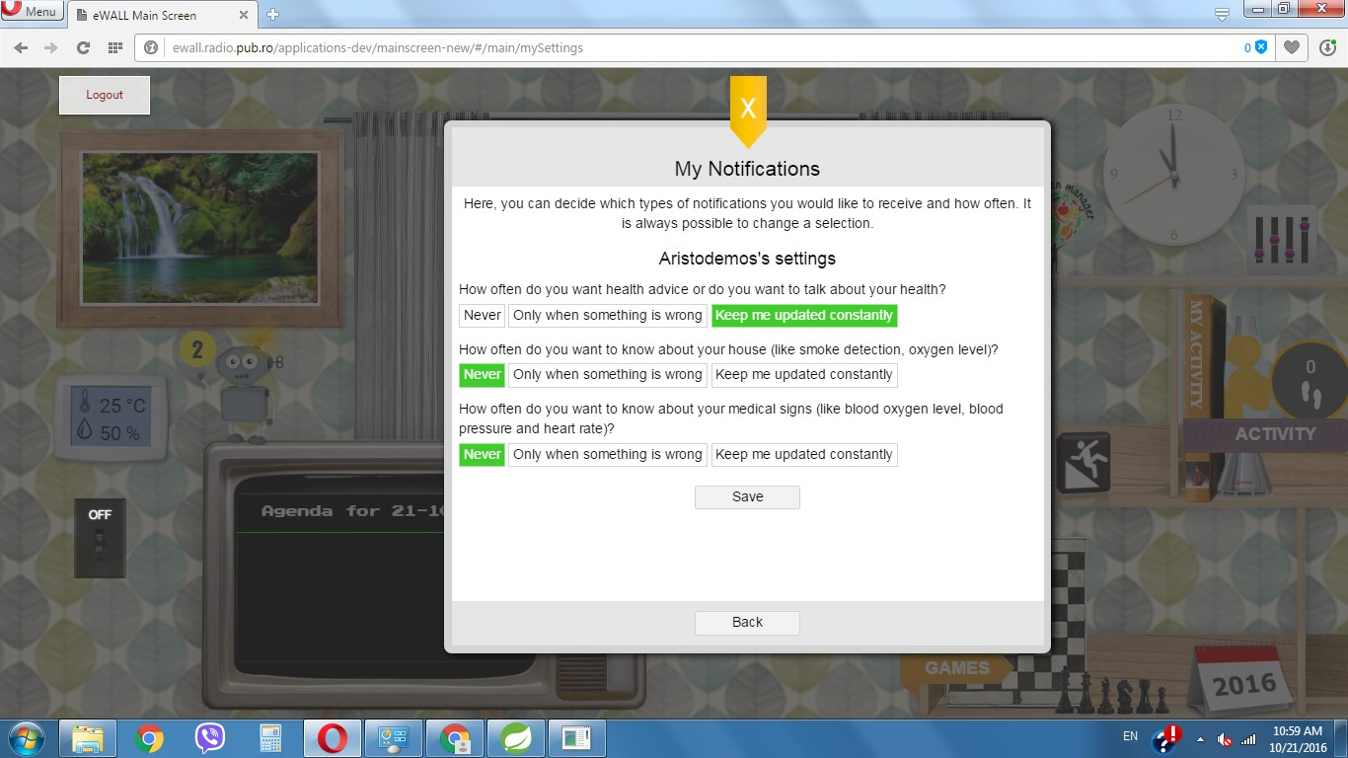

Figure 117: “My notifications”

The “My eWall Appearance” menu gives the user possibility to arrange his main screen (Figure 118). He has the choice to select from three different wallpapers by clicking on them. “Back” the user returns back to main page of the app. The user has the choice to select which books and games wants to be shown on his main screen. The selected book is paint in orange while non-selected are in white. Family picture and eWall photos are the selections for the photo frame. The selected one is in green. And the last selection is for the screensaver – “ON” and “OFF”. The selected one is in green. User changes must be saved by clicking ‘Save’. With “Back” the user returns back to main page of the app.

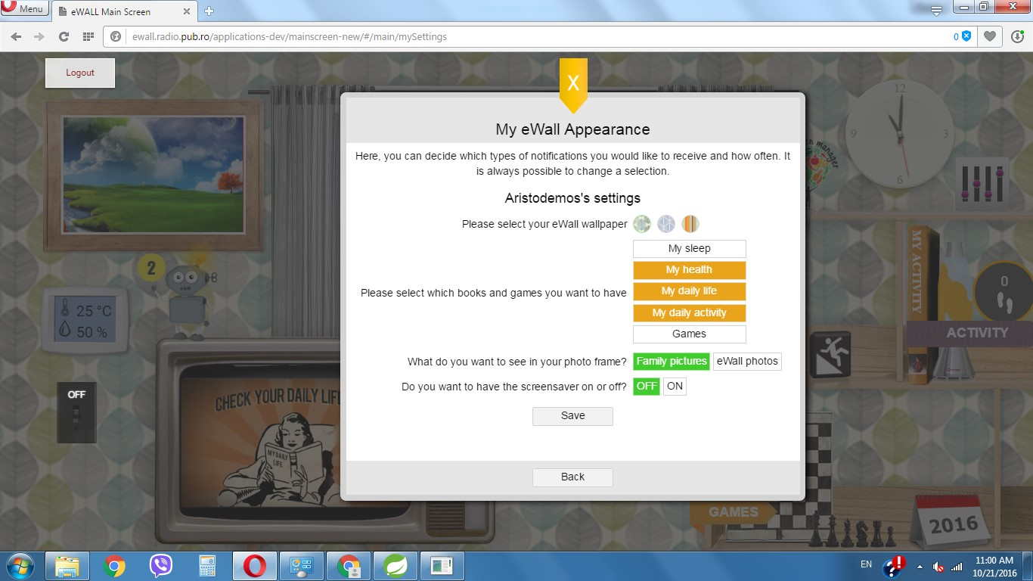

Figure 118: “My eWall Appearance”

## My Kitchen Manager Application

*MyKitchenManager* is an application for managing the ingredients the user has in the fridge or pantry, planning what needs to be bought and exploring recipes.

It is launched from the eWALL main screen using an icon on the top of the shelves (cf. Figure 119).

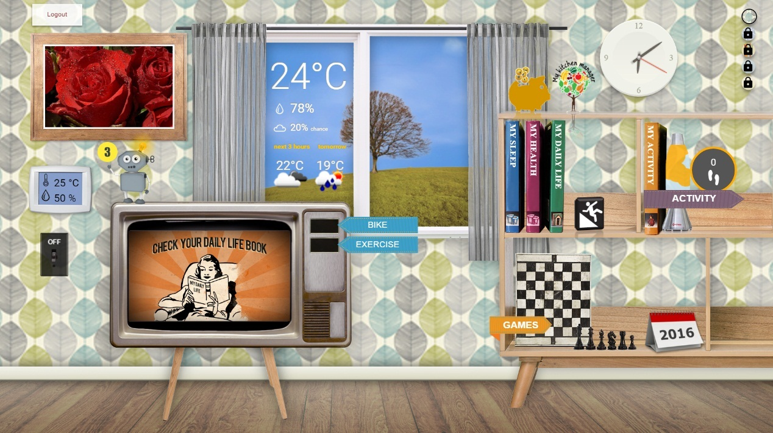

Figure 119: Access to the MyKichenManager from the main screen

The user is welcomed by an overview screen that gives a brief overview of the functionality and allows access to the five screens of the application:

* Overview,
* Fridge management,
* Pantry management,
* Recipes browse and search, and
* Shopping list management

Access to the screens is achieved via the five large icons on the left-hand side (cf. Figure 120).

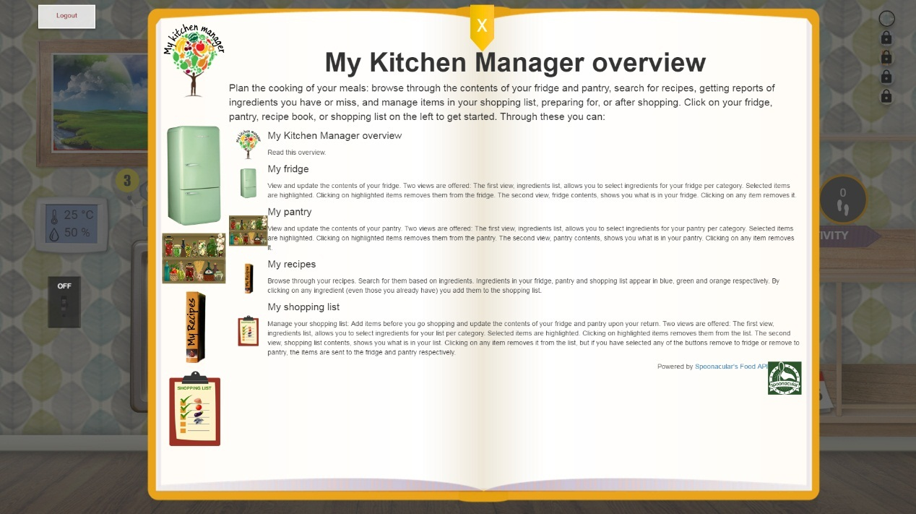

Figure 120: MyKichenmanager overview screen

Upon selecting the fridge, the user can see its contents or browse through ingredients to add. These are the “Ingredients list” and “Fridge contents” views, to be accessed by the orange buttons. The button of the active view is turned red. In the “Fridge contents” view, all ingredients are bundled together, but in the “Ingredients list” view, they are categorized per supermarket aisle they are usually to be found. The aisle of interest is selected using the group of cyan buttons. Any selected item for the fridge is shown in blue. In both views, clicking on an ingredient marked as being in the fridge, removes it. All these are shown in the following screenshot (cf. Figure 121).

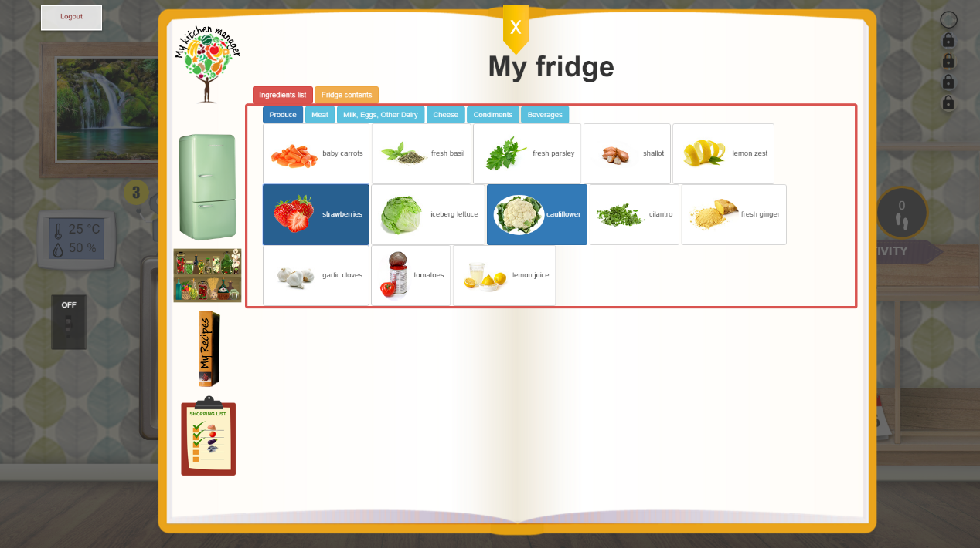

Selected ingredient for fridge

Select aisle

Select view

Figure 121: My Fridge content

The pantry screen works the same way, only different aisles are shown, since in the two screens only the meaningful aisles for each are shown.

The shopping list screen is also similar, with two differences: In the “Ingredients list” view all aisles are shown to make a selection, while in the “Shopping list contents” (cf. Figure 122) view has two buttons on top of the selected ingredients. These are to be used after shopping, to arrange the bought items in the fridge and pantry. Activating any of the two and then clicking on a list item removes it from the list, but adds it to the fridge or pantry respectively. Clicking at an ingredient with both buttons deselected just removes it from the list.

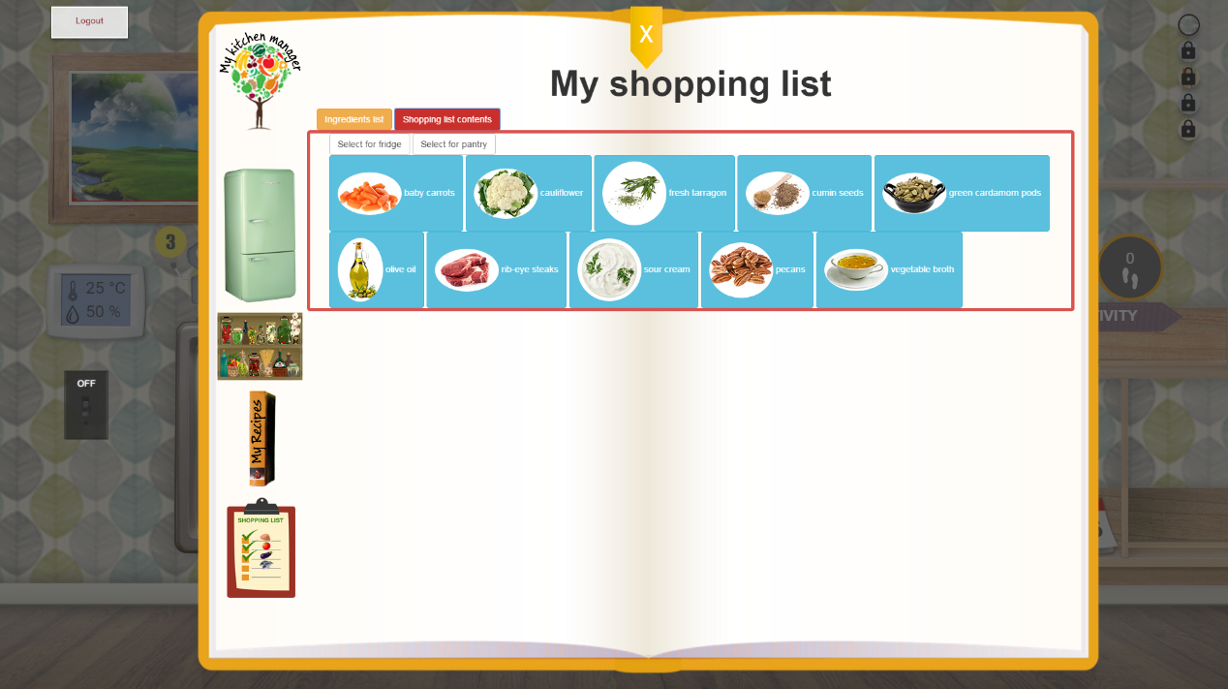

Arrange where ingredient goes upon clicking on it

Figure 122: My Shopping List

Finally, the Recipes screen (cf. Figure 123) allows browsing the available recipes or searching for them based on any number of ingredients. Recipes are presented with an image, a list of ingredients and some instructions text. The ingredients on the list are colored blue if they are to be found in the fridge, green if they are to be found in the pantry, and orange if they are added to the shopping list. Clicking on any ingredient adds it to the shopping list.

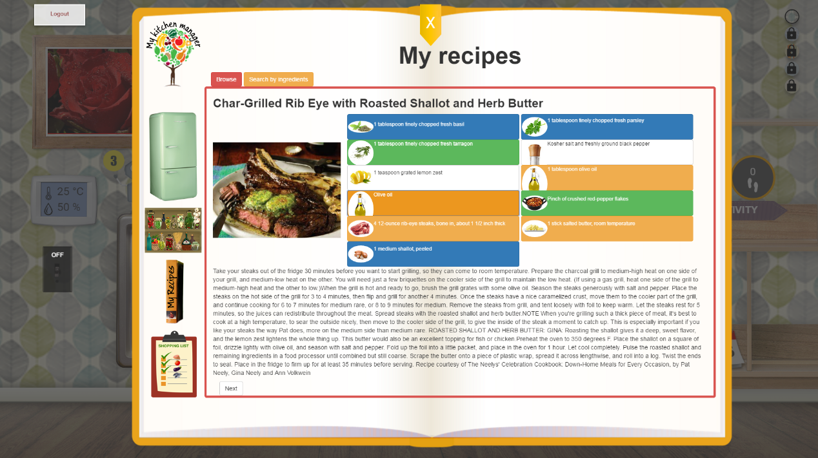

Figure 123: My recipes screen

Recipes can also be searched for based on any number of ingredients from all aisles. After ingredients selection, the user clicks on the green search button to search, or on the white one to reset the query ingredients (cf. Figure 124).

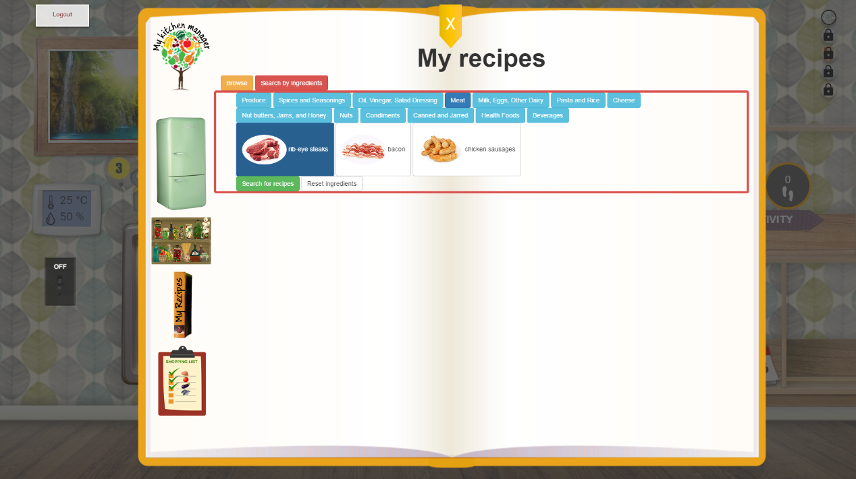

Search or reset buttons

Figure 124: Search by ingredient in My Recipe

The matching recipes are sorted by the number of query ingredients they require. When done browsing the search results, the user can start a new query by clicking on the green “Look for different ingredients” button (cf. Figure 125).

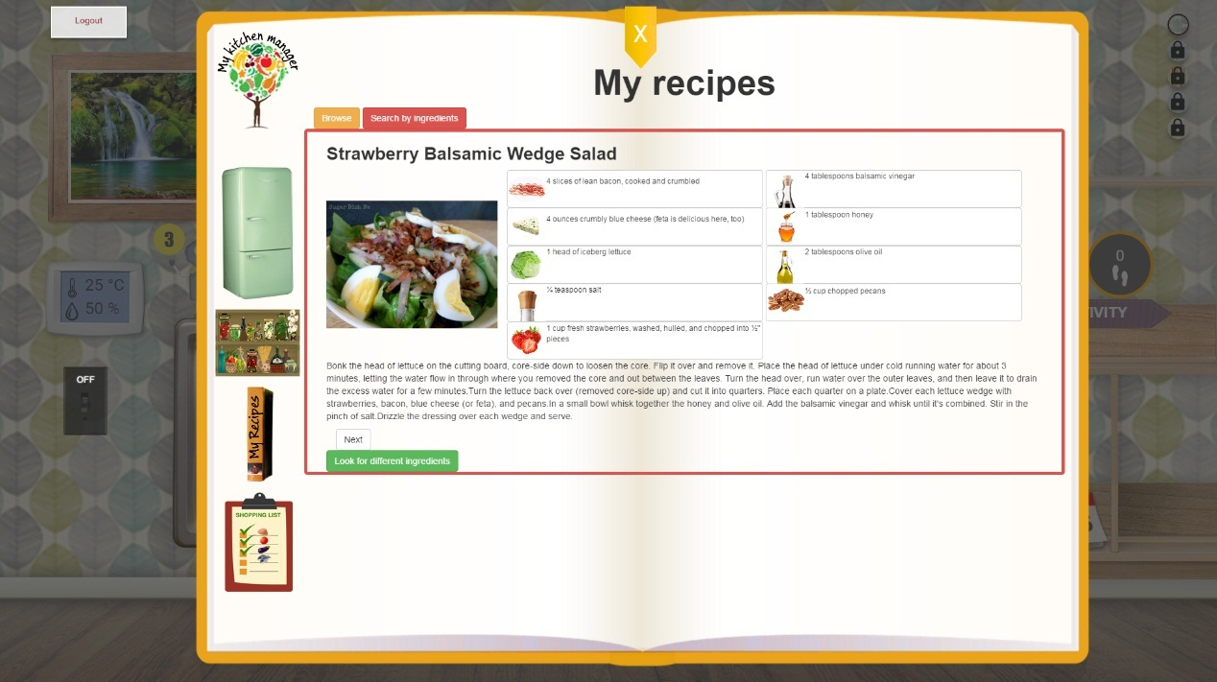

Figure 125: "Look for different ingredient button" in My Recipe

# Bibliography

|  |  |
| --- | --- |
| [1] | R. Fielding, "Chapter 5 of Roy Fielding's dissertation," [Online]. Available: http://www.ics.uci.edu/~fielding/pubs/dissertation/rest_arch_style.htm. [Accessed 24 10 2014]. |
| [2] | "eWALL Deliverable D4.3.2, Cloud middleware services for eWALL,," October 2014. |
| [3] | *Integral of the Modulus of the Accelerometer output.* |
| [4] | "eWALL Deliverable D4.2.2, Intelligent support system for eWALL," October 2014. |
| [5] | "eWALL Deliverable D5.2.2, Lifestyle reasoning: Fusion for activities, situations and their patterns," October 2014. |
| [6] | "eWALLDeliverable D2.7, Final user and system requirements and architecture," February 2015. |
| [7] | "HTML5," [Online]. Available: http://www.w3.org/TR/html5/. |
| [8] | "JavaScript," [Online]. Available: http://www.w3.org/standards/techs/js#w3c_all. |
| [9] | "CSS," [Online]. Available: http://www.w3.org/Style/CSS/. |
| [10] | "Angular JS," [Online]. Available: ttps://angularjs.org/. |
| [11] | "HTML4," [Online]. Available: http://www.w3.org/TR/html401/. |
| [12] | "Document Object Model," [Online]. Available: http://en.wikipedia.org/wiki/Document_Object_Model. |
| [13] | "AJAX," [Online]. Available: http://www.adaptivepath.com/ideas/ajax-new-approach-web-applications/. |
| [14] | "XML," [Online]. Available: http://www.w3.org/TR/REC-xml/. |
| [15] | "JQuery," [Online]. Available: http://jquery.com/. |
| [16] | "Tomcat," [Online]. Available: http://tomcat.apache.org/download-70.cgi. |
| [17] | "Ubuntu," [Online]. Available: http://releases.ubuntu.com/14.04/. |
| [18] | "Apache," [Online]. Available: http://www.apache.org/. |
| [19] | "eWALL eWALL Deliverable D2.7, Final user and system requirements and architecture," February 2015. |
| [20] | "eWALL Deliverable D4.4.2, eWALL Platform," April 2015. |
| [21] | E. J. &. W. J. K. Stepanski, "Use of sleep hygiene in the treatment of insomnia," *Sleep Medicine Reviews,* vol. 7, no. 3, pp. 215-225, 2003. |
| [22] | A. H. J. M. J. M. B. F. C. M. &. R. S. Agusti, "Night-time symptoms: A forgotten dimension of COPD," *European Respiratory Review,* vol. 20, pp. 183-194, 2011. |
| [23] | A. L. P. L. H. M. I. &. B. O. C. Valipour, " Sleep profile and symptoms of sleep disorders in patients with stable mild to moderate chronic obstructive pulmonary disease.," *Sleep Medicine,* vol. 12, no. 4, pp. 367-372, 2011. |
| [24] | M. D. R. &. Q. S. Klink, "The Relation of Sleep Complaints to Respiratory Symptoms in a General Population," *Chest,* vol. 105, no. 1, pp. 151-154, 1994. |
| [25] | "Gartner IT Glossary," [Online]. Available: http://www.gartner.com/it-glossary/context-aware-computing-2. |
| [26] | S. M. S. &. H. J. Thomas, " Does the “Otago exercise programme” reduce mortality and falls in older adults?: A systematic review and meta-analysis.," *Age and Ageing,* vol. 39, no. 6, pp. 681-687, 2010. |
| [27] | H. Z. A. B. S. K. S. M. &. Z. W. Geraedts, " Effects of remote feedback in home-based physical activity interventions for older adults: a systematic review.," *Patient Education and Counseling,* vol. 91, no. 1, pp. 14-24, 2013. |
| [28] | L. D. F. L. L. F.-S. K. G. P. S. W. C. W. M. A. …. C. S. Baker, " Effects of aerobic exercise on mild cognitive impairment: a controlled trial.," *Archives of Neurology,* vol. 67, no. 1, pp. 71-79, 2010. |
| [29] | K. L. F. L. A. O. P. X. J. G. K. R. H. J. …. L. N. T. Cox, "The FABS trial: a randomised control trial of the effects of a 6-month physical activity intervention on adherence and long-term physical," vol. 57, no. 6, pp. 824-830, 2013. |
| [30] | S. N. W. K. H. S. M. T. T. &. L. J.-W. J. Vorrink, " Level of daily physical activity in individuals with COPD compared with healthy controls.," *Respiratory Research,* vol. 12, 2011. |
| [31] | B. K. A. M. H. O. M. K.-C. S. M. S. A.-L. …. W. H. Waschki, "Disease Progression and Changes in Physical Activity in Patients with Chronic Obstructive Pulmonary Disease.," *American Journal of Respiratory and Critical care medecine,* vol. 192, no. 3, pp. 295-306, 2015. |
| [32] | R. S. L. M. T. &. T. S. J. C. Sohanpal, "Understanding patient participation behaviour in studies of COPD support programmes such as pulmonary rehabilitation and self-management: a qualitative synthesis with application of theory.," *NPJ Primary care respiratory medicine,* vol. 25, 2015. |
| [33] | M. B.-K. M. v. d. V. P. H. H. &. V.-H. M. Tabak, "A telehealth program for self-management of COPD exacerbations and promotion of an active lifestyle: A pilot randomized controlled trial.," *International journal,* vol. 9, pp. 935-944, 2014. |
| [34] | B. G. S. American Geriatrics Society, "Clinical practice guidelines: prevention of falls in older person," American Geriatric Society, New York, NY, 2010. |
| [35] | A. M. N. T. N. K. O. S. I. K. E. M. O. Y. Kojima T, "Polypharmacy as a risk for fall occurrence in geriatric outpatients.," *Geriatr Gerontol Int,* vol. 12, pp. 425-430, 2012. |
| [36] | S. H. M. A. U. H. S. Y. Park H, " Medications associated with falls in older people: systematic review of publications from a recent 5-year period.," *Eur J Clin Pharmacol.,* vol. 71, no. 12, pp. 1429-1440, 2015. |
| [37] | B. G. S. American Geriatrics Society, "Clinical practice guidelines: prevention of falls in older person.," American Geriatric Society, New York, 2010. |
| [38] | L. P. B. A. C. M. B. M. K. G. Wood JM, "Risk of falls, injurious falls, and other injuries resulting from visual impairment among older adults with age-related macular degeneration," *Invest Ophthalmol Vis Sci. ,* vol. 52, no. 8, pp. 5088-5092, 2011. |
| [39] | D. N. M. H. B. S. R. K. Brenton-Rule A, "Foot and ankle characteristics associated with falls in adults with established rheumatoid arthritis: a cross-sectional study.," *BMC Musculoskelet Disord.,* vol. 17, no. 1, 2016. |
| [40] | M. M. L. S. Menz HB, " Foot and ankle risk factors for falls in older people: a prospective study.," *J Gerontol A Biol Sci Med Sci.,* pp. 866-870, 2006. |
| [41] | J. S. T. N. Chaiwanichsiri D, "Foot disorders and falls in older persons. Gerontology.," vol. 55, no. 3, pp. 296-302, 2009. |
| [42] | S. M. M. I. D. S. V. H. Janssen HP, "Strenght, mobility and falling in women referred to a geriatric outpatient clinic.," *Aging Clin Exp Res,* vol. 16, no. 2, pp. 122-125, 2004. |
| [43] | E. T. J. B. Jorgensen L, "[79High incidence of falls in long term stroke survivors than in population control: depressive symptom predict falls after stroke.," vol. 33, pp. 542-547, 2002. |
| [44] | C. J. F. A. G. D. Biderman A, "Depression and falls among community dwelling elder people. A search for common risk factors.," *J Epidemiol Community Health,* vol. 56, pp. 631-636, 2002. |
| [45] | W. S. R. L. B. R. G. P. Vellas BJ, "Fear of falling and restriction of morbility in elderly fallers.," *Age Ageing,* vol. 26, no. 3, pp. 189-193, 1997. |
| [46] | K. C. Tinetti ME, "The patient who falls: “It’s always a trade-off”," *JAMA 2010,* vol. 303, no. 3, pp. 258-266. |
| [47] | W. S. R. L. B. R. G. P. Vellas BJ, "Fear of falling and restriction of morbility in elderly fallers.," *Age Ageing. ,* vol. 26, no. 3, pp. 189-193, 1997. |
| [48] | H. D. L. a. m. I. F. A. R. W. (. Howard JH, Handbook of Human Factors and the Older Adult, New York: Academic, 1996. |
| [49] | S. G. W. S. I. R. T. E. K. E. Petersen RC, "Mild cognitive impairment: clinical characterization and outcome.," *Arch. Neurol. ,* vol. 56, no. 3, p. 3038, 2009. |
| [50] | A. Association, " Alzheimer’s Disease Facts and Figures. Alzheimer’s & Dementia.," 2015. |
| [51] | "UCSF Memory and Aging Center. Mild Cognitive Impairment.," 2013. |
| [52] | B. L. V. S. e. a. Jefferson AL, "Characterization of activities of daily living in individuals with mild cognitive impairment," *Am J Geriatr Psychiatry,* 2008. |
| [53] | M. D. R. B. H. D. C.-W. D. D. C. Farias ST, "MCI is associated with deficits in everyday functioning.," *Alzheimer Dis Assoc Disord ,* vol. 20, no. 4, pp. 217-223, 2006. |
| [54] | L. L. C. H. L. V. Tam CW, "Characteristic profiles of instrumental activities of daily living in Chinese older persons with mild cognitive impairment.," *Am J Alzheimers Dis Other Demen,* vol. 22, no. 3, pp. 211-217, 2007. |
| [55] | F. G. W. R. Purser JL, "Memory complaint is not necessary for diagnosis of mild cognitive impairment and does not predict 10-year trajectories of functional disability, word recall, or short portable mental status questionnaire limitati," *J Am Geriatr Soc,* vol. 54, no. 2, pp. 335-338, 2006. |
| [56] | C. V. F. C. O. J. D. J. B.-G. P. Pérès K, "Restriction in complex activities of daily living in MCI: impact on outcome," *Neurology,* vol. 67, no. 3, pp. 461-466, 2006. |
| [57] | T. e. al., "Progression of Mild Cognitive Impairment to Dementia in Clinics Community-Based Cohorts.," *Arch Neurol. ,* vol. 66, no. 9, pp. 1151-1157, 2009. |
| [58] | [Online]. Available: https://www.nia.nih.gov/alzheimers/features/encouraging-eating-advice-home-dementia-caregivers. |
| [59] | A.-I. S., "Sleep and its disorders in aging populations.," *Sleep Med.,* vol. 10, pp. 7-11, 2009. |
| [60] | e. a. Naismith SL, "Circadian misalignment and sleep disruption in mild cognitive impairment," *J Alzheimers Dis. ,* vol. 38, no. 4, pp. 857-866, 2014. |
| [61] | M. C., "Mantelzorg en dementie. Een zorg op zich. Utrecht: Expertisecentrum Informele Zorg, NIZW Zorg.," 2005. |
| [62] | v. d. B. S. T. J. Joosten L, "Help me even herinneren; Een gids voor mensen met milde geheugenproblemen en hun naasten.," 2008. |
| [63] | "Mayo Clinic. Mild cognitive impairment (MCI).," 2012. |
| [64] | M. K. T. A. Anderson ND, "Living with Mild Cognitive Impairment: A Guide to Maximizing Brain Health and Reducing Risk of Dementia.," 2015. |
| [65] | L. D. Langa KM, "The Diagnosis and Management of Mild Cognitive Impairment: A Clinical Review.". |
| [66] | V. B., "The future of home and community based long term care," *Aging Research & Policy Report,* vol. 8, pp. 25-30, 1998. |
| [67] | C. V. F. C. O. J. D. J. B.-G. P. Pérès K, " Restriction in complex activities of daily living in MCI: impact on outcome.," *Neurology ,* pp. 461-466, 2006. |
| [68] | "Family Caregiver Alliance. Mild Cognitive Impairment (MCI).," 2012. |
| [69] | "Roessingh Research and Development. Health Monitoring Application for elderly with MCI.," 2016. |
| [70] | A. Association, "Living Well; A Guide for Persons with Mild Cognitive Impairment (MCI) & Early Dementia.," 2015. |
| [71] | "World Health Organization. Dementia. Fact sheet N°362.," 2015. |
| [72] | C. KJ., " Low indoor temperatures and morbidity in the elderly. Age Ageing.," 1986. |
| [73] | W. M.L., The complete guide to Alzheimer’s proofing your home., West Lafayette: Purdue University Press. , 2000. |
| [74] | O. G.-O. A. Zuckerman, "[116Deconstructing gamification: evaluating the effectiveness of continuous measurement, virtual rewards, and social comparison for promoting physical activity. Personal and Ubiquitous Comput," pp. 1705-1719, 2014. |
| [75] | E. A. L. G. P. Locke, "Building a Practically Useful Theory of Goal Setting and Task Motivation: A 35-Year Odyssey.," *American Psychologist,* vol. 57, no. 9, pp. 705-717, 2002. |
| [76] | v. d. G. T. v. d. W. L. v. d. B. S. S. M. van Velsen L, " Personalization has a Price, Controllability is the Currency: Predictors for the Intention to use Personalized eGovernment Websites.," *J Organ Comput Electron Commer,* 2010. |
| [77] | "eWALL Deliverable D5.1.2 eWall metadata from the outside: filtered and retrieved," April 2015. |
| [78] | S. L. T. M. M. K. B. J. E. K. M. K. J. N. M. G. W. R. F. W. U. A. M. S. a. E. W. Sherry L. Willis, "Long-term Effects of Cognitive Training on Everyday Functional Outcomes in Older Adults," *JAMA,* vol. 296, 2006. |
| [79] | "Likert," [Online]. Available: http://en.wikipedia.org/wiki/Likert_scale. |
| [80] | "eWALL Deliverable D4.1.2, Semantic model of eWALL middleware services," October 2014. |
| [81] | "eWALL Deliverable D3.1.2, eWALL Networked Devices," October 2014. |
| [82] | "eWALL Deliverable D3.2.2, Perception from sensors," October 2014. |
| [83] | "eWALL Deliverable D2.2, Initial Scenarios and Use-Cases v1.0," February 2014. |
| [84] | "eWALL Deliverable D2.1, Preliminary User and System Requirements v1.0," February 2014. |
| [85] | "Context awareness," [Online]. Available: http://en.wikipedia.org/wiki/Context_awareness. [Accessed 12 02 2015]. |
| [86] | "Open source software to collaborate on code," [Online]. Available: https://about.gitlab.com/. |
| [87] | C. e. al., " Energy Expenditure of Walking and Running," *Medicine & Science in Sport & Exercise,* Dec. 2004. |
| [88] | "Basal metabolic rate," [Online]. Available: http://en.wikipedia.org/wiki/Basal_metabolic_rate. |
| [89] | B. K. McNab, "On the Utility of Uniformity in the Definition of Basal Rate of Metabolism," *Physiol. Zool,* vol. 70, pp. 718-720, 1997. |
| [90] | J. Janot, "Calculating Caloric Expenditure," *IDEA Fitness Journal,* 2005. |
| [91] | "WIN steps project,Steps Conversions," [Online]. Available: www.uwyo.edu/wintherockies. |
| [92] | P. R. C. C. R. W. V. S. R. A. T. L. C. Tudor-Locke C, " BMI-referenced standards for recommended pedometer-determined steps/day in children," *Prev Med. Jun,* vol. 38, no. 6, pp. 857-864, 2004. |
| [93] | B. Y. a. R. M. A. X. Long, "Single-accelerometer-based daily physical activity classification," in *Annual International Conference of the IEEE in Engineering in Medicine and Biology Society*, 2009. |
| [94] | "Autoregressive model," [Online]. Available: http://en.wikipedia.org/wiki/Autoregressive_model. |
| [95] | "Signal magnitude area," [Online]. Available: http://en.wikipedia.org/wiki/Signal_magnitude_area. |
| [96] | J. Burg, "A new analysis technique for time series data," in *Advanced Study Institute on Signal Processing, NATO*, Enschede, Netherlands, 1968. |
| [97] | M. Pedley, "Tilt sensing using a three-axis accelerometer," Freescale Semiconductor Application Note, 2013. |
| [98] | C. J. Burges, "A tutorial on support vector machines for pattern recognition," *Data Mining and Knowledge Discovery,* vol. 2, pp. 121-167, 1998. |
| [99] | M. Z. a. A. A. Sawchuk, "A daily activity dataset for ubiquitous activity recognition using wearable sensors," in *CM International Conference on Ubiquitous Computing (Ubicomp) Workshop on Situation, Activity and Goal Awareness*. |
| [100] | C.-C. C. a. C.-J. Lin, "LIBSVM: A library for support vector machines," *ACM Transactions on Intelligent Systems and Technology,* pp. 1-27, 2011. |
| [101] | K. Denecke, "Using sentiwordnet for multilingual sentiment analysis," in *Data Engineering Workshop, 2008. ICDEW 2008. IEEE 24th International Conference on*, 2008. |
| [102] | J. A. Russell, "A circumplex model of affect," *Journal of personality and social psychology,* vol. 39, no. 6, p. 1161, 1980. |
| [103] | "Karhunen-Loeve theorem," [Online]. Available: http://en.wikipedia.org/wiki/Karhunen%E2%80%93Lo%C3%A8ve_theorem. |
| [104] | "Sentiword dataset," [Online]. Available: http://sentiwordnet.isti.cnr.it/. |
| [105] | "eWALL caregiver app," [Online]. Available: http://ewall.radio.pub.ro/applications-dev/service-brick-caregiver-webapp. |
| [106] | "American Sleep Disorders Association, Diagnostic Classification Steering Committee. International Classification of Sleep Disorders: Diagnostic and Coding Manual, ICSD-R.," American Academy of Sleep Medicine, Westchester, 2005. |
| [107] | V. M., "Sleep Disorders and Aging: Understanding the Causes.," *Journal of Gerontology: Medical Sciences,* vol. 52A, no. 4, 1997. |
| [108] | O. M. e. al., "Meta-Analysis of Quantitative Sleep Parameters from Childhood to Old Age in Healthy Individuals: Developing Normative Sleep Values Across the Human Lifespan.," *SLEEP,* vol. 27, no. 7, 2004. |
| [109] | A.-I. e. al., "Sleep in the Elderly: Normal Variations and Common Sleep Disorders," *Harvard Review of Psychiatry,* vol. 16, no. 5, 2008. |
| [110] | Killgore, "Effects of sleep deprivation on cognition," *Progress in Brain Research,* vol. 185, 2010. |
| [111] | J. e. al., "The incidence and temporal patterning of insomnia: a pilot study.," *Journal of Sleep Research,* vol. 19, no. 1, pp. 31-35, 2010. |
| [112] | C. e. al., "The Consensus Sleep Diary: Standardizing Prospective Sleep Self-Monitoring.," *SLEEP,* vol. 35, no. 2, 2012. |
| [113] | A. Schmidt, "Ubiquitous Computing - Computing in Context, a thesis on Context-Awareness, Context Aware Computing, and Ubiquitous Computing," November 2002. |